**Dependent variable**

$popularity = (average star -3) ×log (number of reviews)$

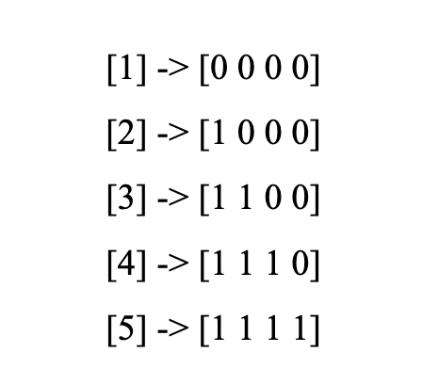

**Independent variables**

Review: text, review stars, (polarity, subjectivity)

User: review_count, since_year, (X elite)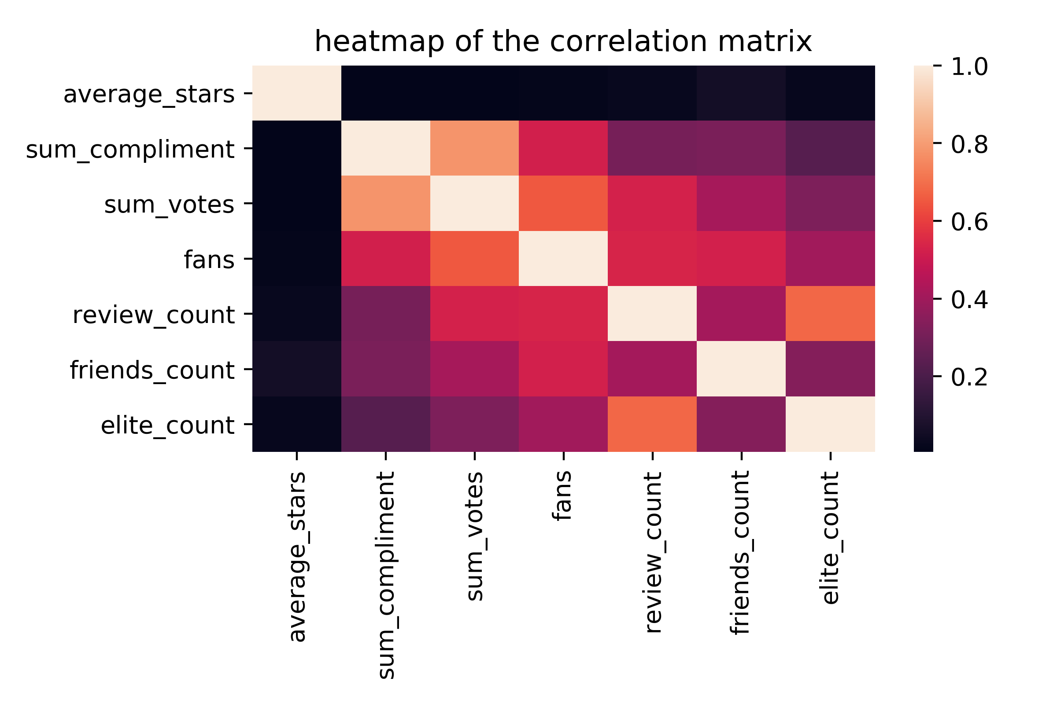

Restaurant: review counts based on cities

-------------

Weights: **useful+funny+cool**

**Assumption**

User

Time

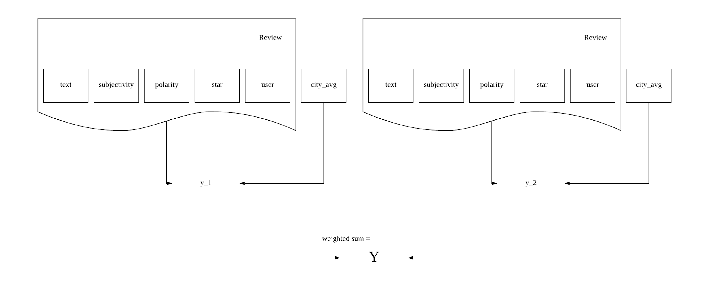

**Models**

Naive Bayes

Decision tree

Bagging (random forest)

SVM

XGBoost - Choya

**Estimation**

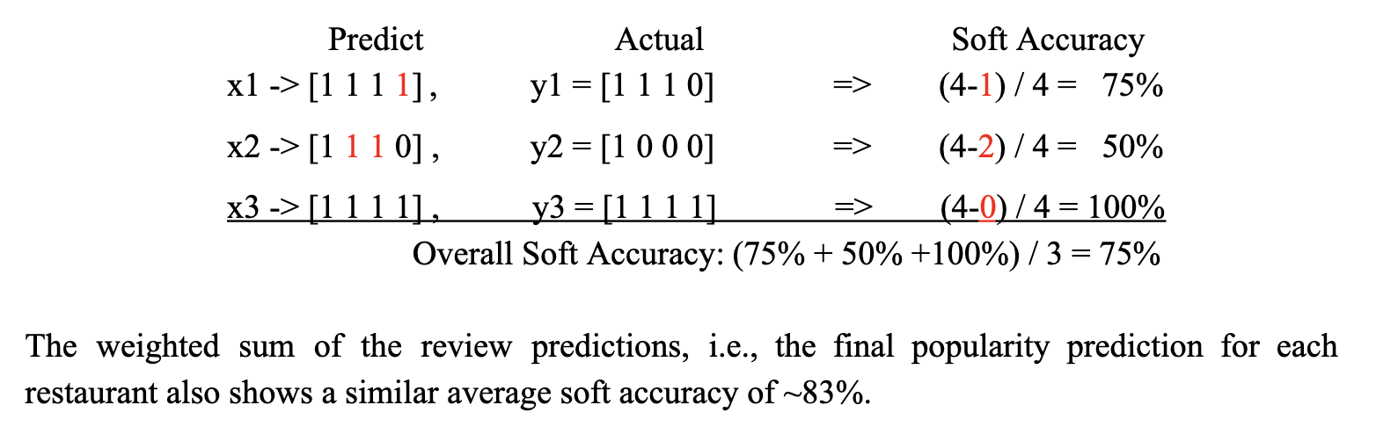

**Others**

1. Filter restaurants that exist before 2018 and are still open